Task 1: Big Data in Daily Life – Visual Storytelling

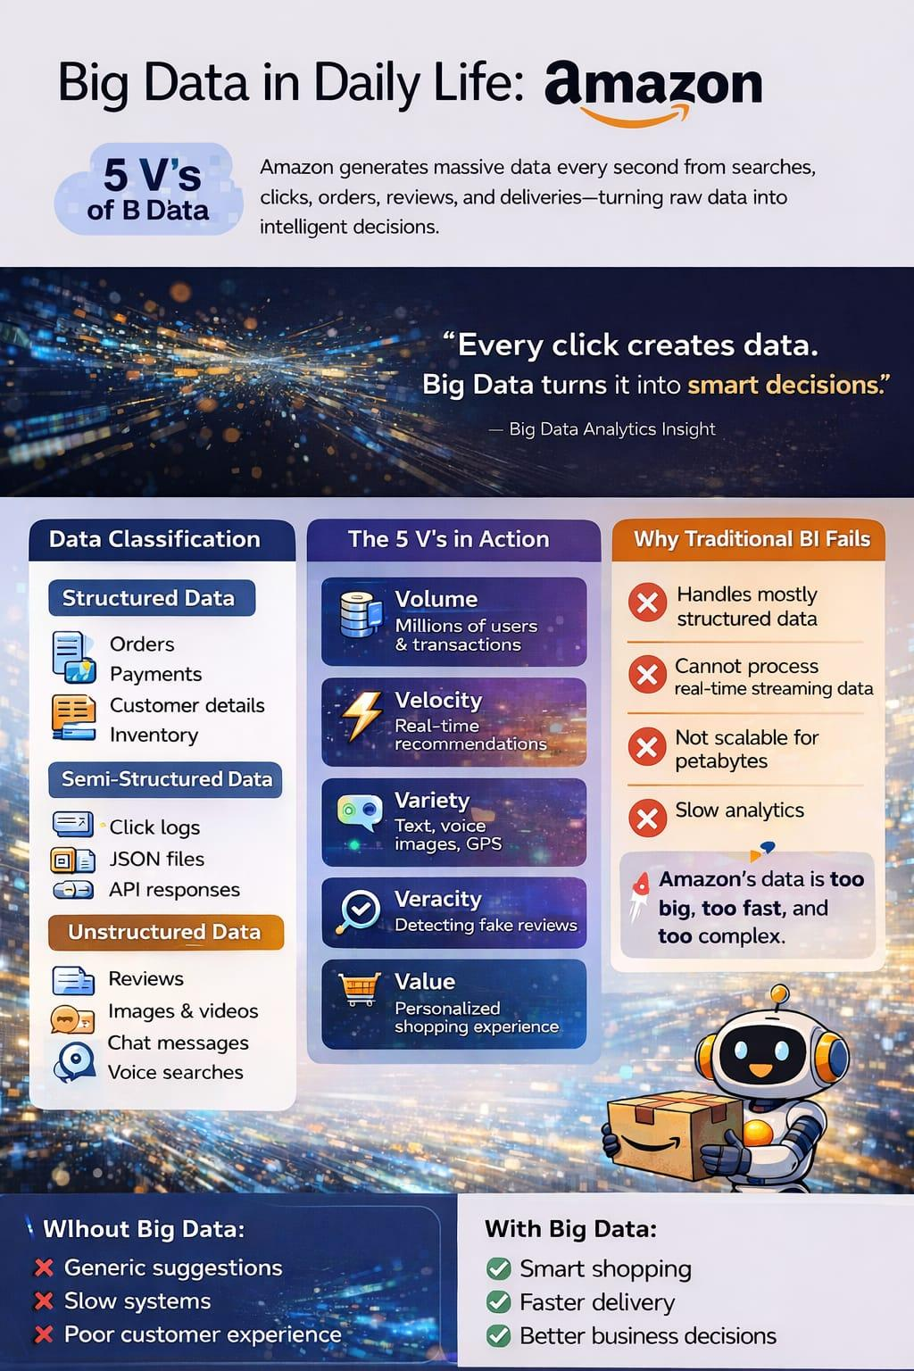

This poster explains how Big Data works in Amazon’s daily operations. It shows the 5 V’s of Big Data — Volume, Velocity, Variety, Veracity, and Value — and how Amazon collects huge amounts of structured, semi-structured, and unstructured data like orders, click logs, reviews, and images.
The poster also highlights why traditional Business Intelligence (BI) systems fail to handle Amazon’s fast and complex data, and how Big Data helps provide smart recommendations, faster delivery, and better customer experience.In short, it shows how Amazon turns massive data into intelligent business decisions.

